**Case Study – Lead Score**

**Assignment Subjective Questions**

|  |  |
| --- | --- |
| Group Name | **Mind Benders** |
| Team Member 1 | **Rahul Kumar** |
| Team Member 2 | [**Adithya**](mailto:Rahul.cs068@gmail.com) **Chadalawada** |
| Course | **PGDDS** |
| Batch | **Dec 2018** |

1. Which are the top three variables in your model which contribute most towards the probability of a lead getting converted?

* The Top three variables in our model which contribute the most towards the probability of a lead getting converted or not are as follows:

a. **Last Notable Activity**

Dummy variable - last_notable_activity_had_a_phone_conversation

b. **Lead Origin**

Dummy variable - lead_origin_lead_add_form

c. **Current Occupation**

Dummy variable - current_occupation_working_professional

1. What are the top 3 categorical/dummy variables in the model which should be focused the most on in order to increase the probability of lead conversion?

* The Top 3 Categorical/Dummy variable in the model which should be focused the most on in order to increase the probability of lead conversion are as follows:
  1. **Last_notable_activity_had_a_phone_conversation**
* with a positive coefficient of **3.68**
  1. **Lead_origin_lead_add_form**
* with a positive coefficient of **2.52**
  1. **Current_occupation_working_professional**
* with a positive coefficient of **2.51**

1. X Education has a period of 2 months every year during which they hire some interns. The sales team, in particular, has around 10 interns allotted to them. So during this phase, they wish to make the lead conversion more aggressive. So they want almost all of the potential leads (i.e. the customers who have been predicted as 1 by the model) to be converted and hence, want to make phone calls to as much of such people as possible. Suggest a good strategy they should employ at this stage.

* The various projected leads for different probability cut-offs for the given model are as per the table below:

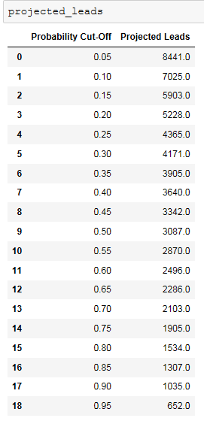

As can be seen from the above table, for lower probability cut-off the projected leads generated is higher i.e., cut-off probability is inversely proportional to projected leads generated.

In scenarios where we have additional people in the sales team for making calls, we can reduce the probability cut-off to get a higher number of projected leads. Since the optimal cut-off has been derived as 0.47, we can set the cut-off lesser than 0.47 to get higher projected leads. The cut-off can be set as low as 0.35 which would generate 3905 projected leads (an increase of 1000!) which can then be distributed among the sales team to try for conversion. The number of projected leads generated can be further increased by further decreasing the cut-off. However, caution needs to be maintained since lowering the cut-off would also decrease the precision. Thus the model can be molded to adapt as per this requirement of X-Education.

1. Similarly, at times, the company reaches its target for a quarter before the deadline. During this time, the company wants the sales team to focus on some new work as well. So during this time, the company’s aim is to not make phone calls unless it’s extremely necessary, i.e. they want to minimize the rate of useless phone calls. Suggest a strategy they should employ at this stage

* The various projected leads for different probability cut-offs for the given model are as per the table below:



As can be seen from the above table, for lower probability cut-off the projected leads generated is higher i.e., cut-off probability is inversely proportional to projected leads generated.

In scenarios where the quarterly deadlines have been already been met and the team is being engaged in other official activities, we would want only those projected leads with a high probability of conversion to be contacted for conversion**.** Since the optimal cut-off has been derived as 0.47, we can set the cut-off much higher than 0.47 to get a lesser number of projected leads.

For example, the cut-off can be set as high as 0.85 which would generate only 1035 projected leads (Decrease **of 2000!**) which can then be contacted by the team to try for conversion. The number of projected leads generated can be further reduced by further increasing the cut-off.

Now, the precision of these projected leads would be very highand the company should make phone calls to only these since they are very highly likely to convert and thus necessary.

Therefore, using this strategy the number of useless phone calls would be minimized, since phone calls would be made only to those leads that are very Hot, i.e. very highly likely to convert.

Thus the model can be moulded and adapted as per this requirement of X-Education also!

--------------------------------- End of File ----------------------------------